**Arduino-based Redox Measurement System**

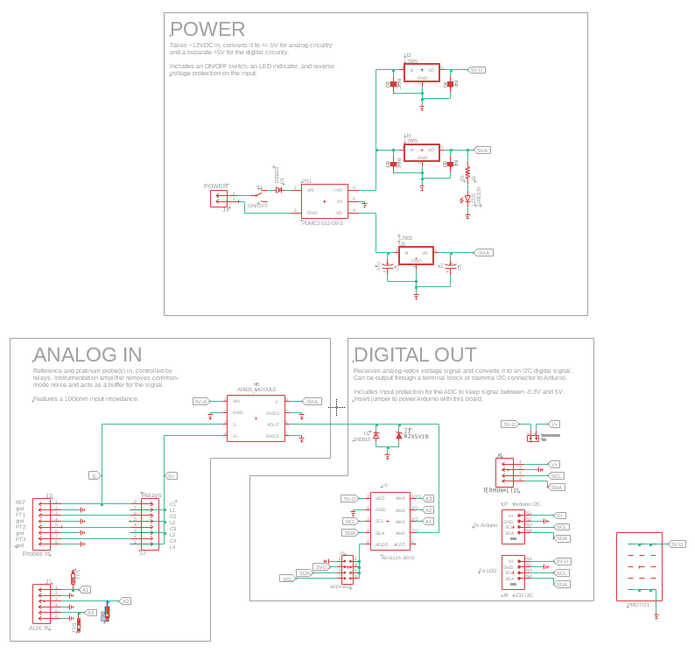

Schematic for Redox V1.1

PCB layout for Redox V1.1

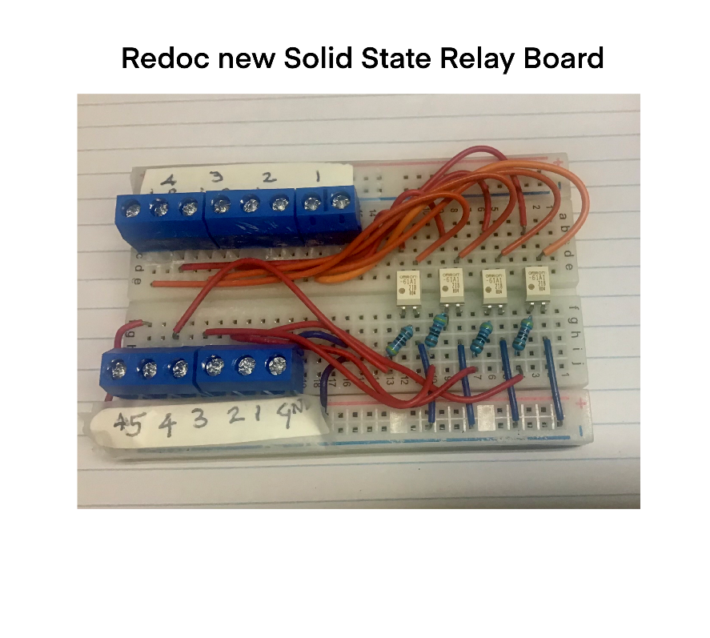

SSR board (Prototype)

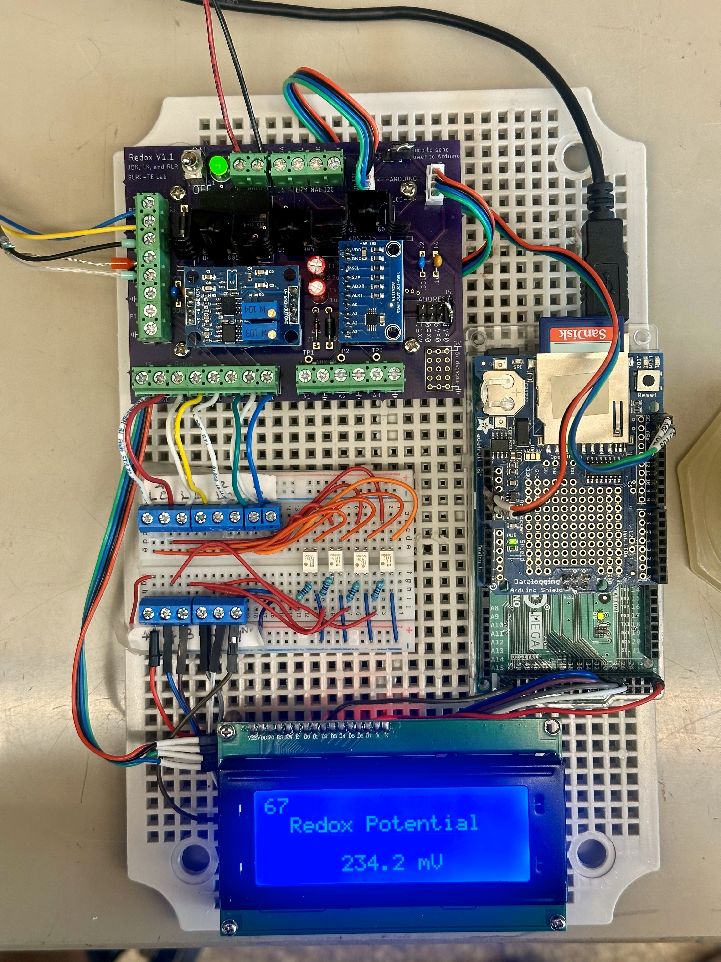

Redox Setup (Prototype)

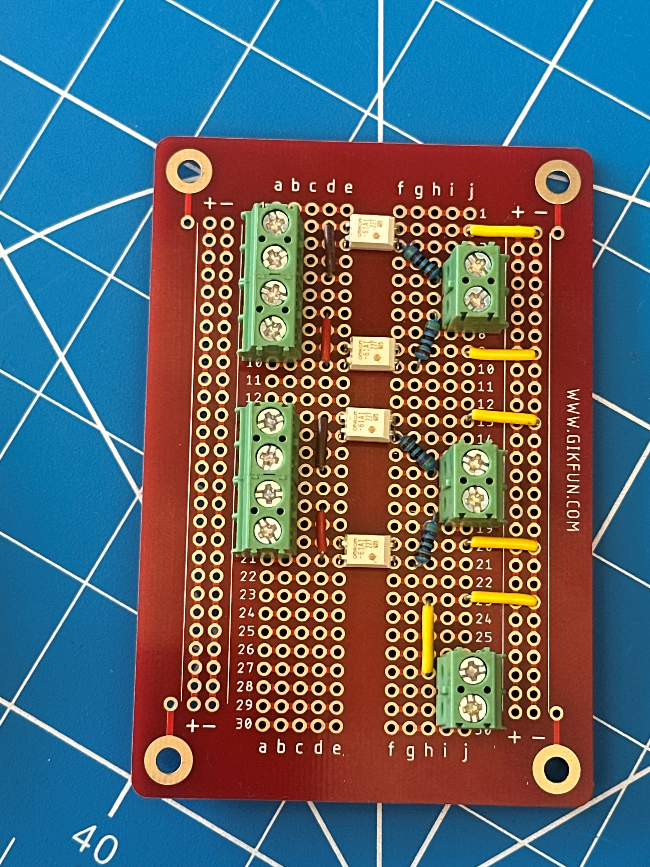

SSR board for field deployment

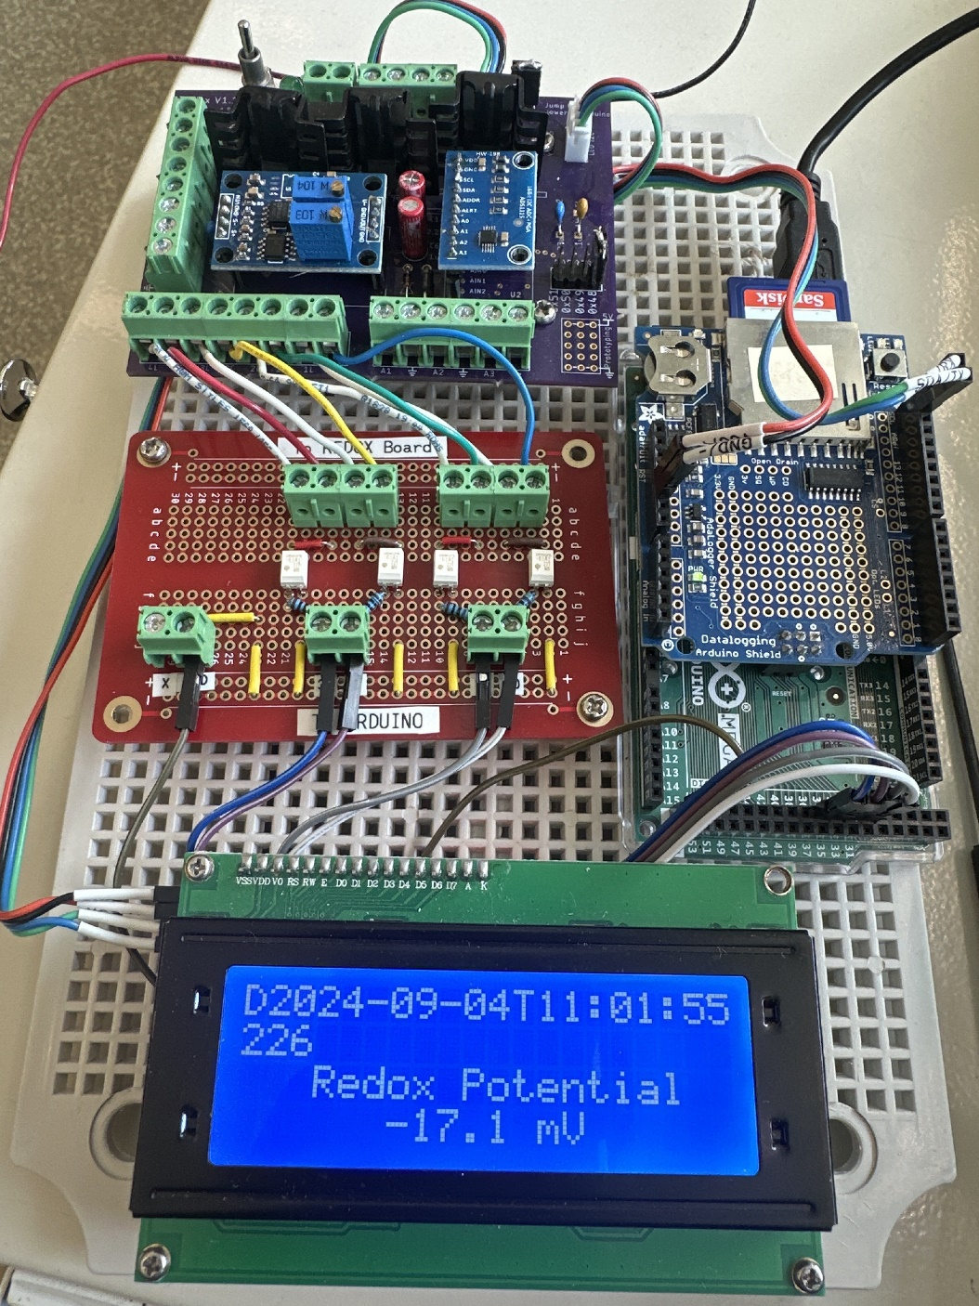

Final Redox Setup for field deployment

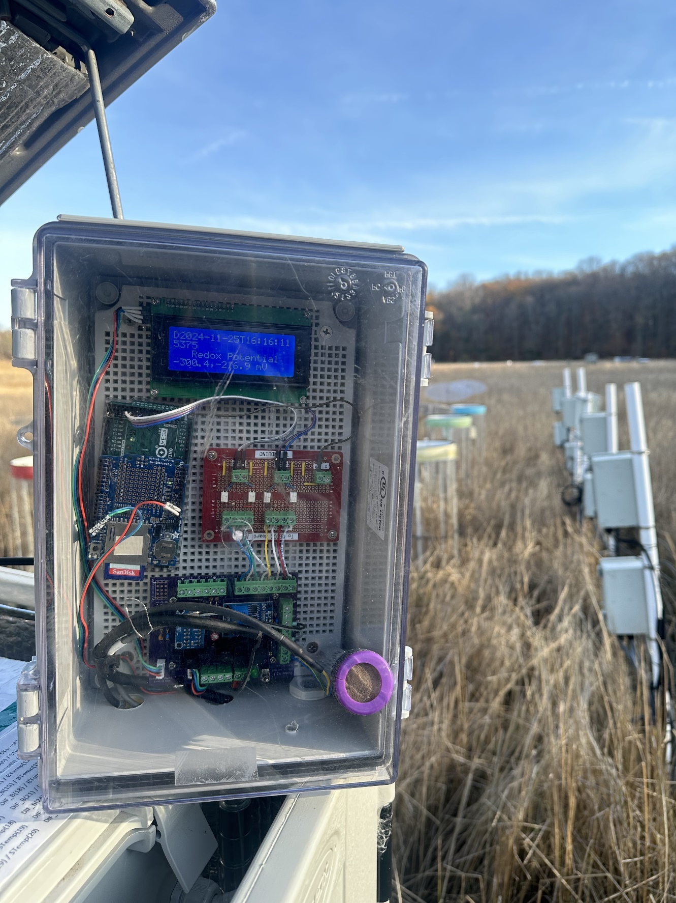

Field deployment